**Export Paginated Report To File**

The Power BI REST APIs provide service endpoints for embedding, administration, governance and user resources.

With Power BI REST APIs you can do the following:

* Manage Power BI content
* Perform admin operations
* Embed Power BI Content

Power Bi Rest APIs

[Power BI REST APIs for embedded analytics and automation - Power BI REST API | Microsoft Learn](https://learn.microsoft.com/en-us/rest/api/power-bi/)

The exportToFile API enables exporting a Power BI paginated report by using a REST call.

When you create an export job, there are three steps to follow:

1. **Sending an export request.**

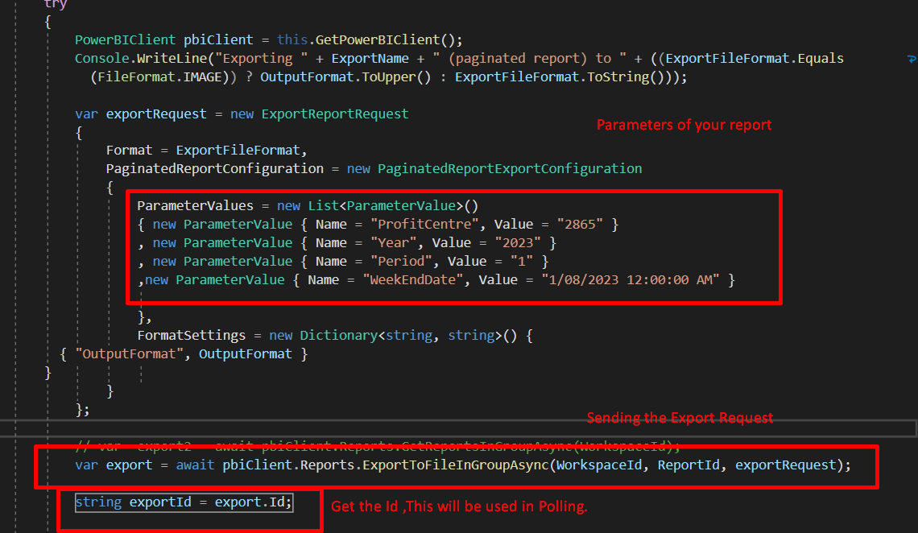

1. **Polling.**

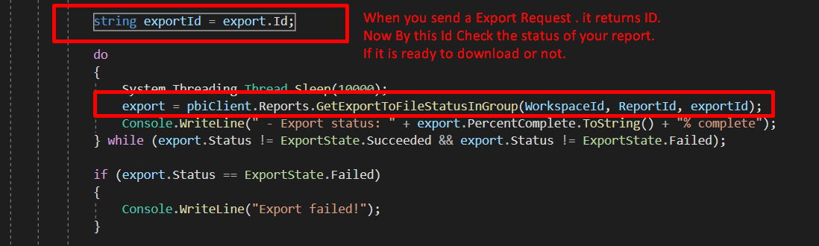

1. **Getting the file.**

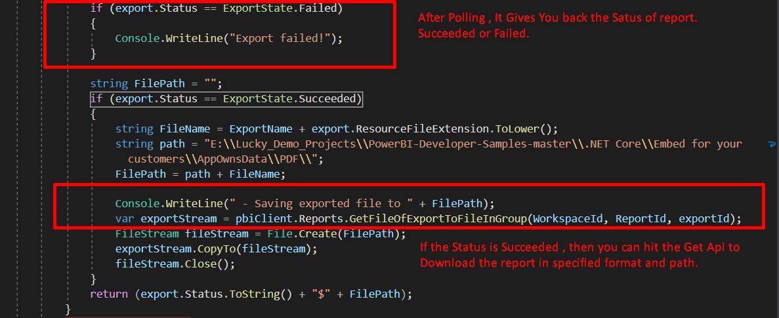

**Supported Features**

* Format settings
* Report parameters
* Authentication

## **Concurrent requests**

The exportToFile API supports concurrent export job requests. The maximum number of concurrent report pages depends on the type and number of SKUs you have. It's not the same number as for other Power BI reports. If you exceed the limit and get a Too Many Requests (429) error, try to distribute the load over time or get a larger capacity.

* when using [Premium Per User (PPU)](https://learn.microsoft.com/en-us/power-bi/enterprise/service-premium-per-user-faq), the exportToFile API allows just one request in a five-minute window. Multiple requests within a five-minute window will result in a Too Many Requests (429) error.

## **Considerations and limitations**

Export of a report is limited to 60 minutes, which matches the life of the user access token.

If you get a timeout error past the 60-minute mark while exporting large amounts of data, consider reducing the amount of data using appropriate filters.

When exporting a paginated report with an effective identity, the username must be an existing user from your tenant’s Azure Active Directory.

Documentation Link to Export Paginated Report To File

[Export Power BI embedded analytics paginated reports API - Power BI | Microsoft Learn](https://learn.microsoft.com/en-us/power-bi/developer/embedded/export-paginated-report)

How To try Export Rest API online to Test

https://community.powerbi.com/t5/Community-Blog/How-to-use-Power-BI-Rest-API-to-export-the-Power-BI-Report-in/ba-p/2179741